Exercise 2 – Dependency Injection

Name: Shubham Sangram Bej

Aim
To implement Dependency Injection using the Spring Framework and configure object dependencies through XML-based bean configuration.

Objective
- To understand Dependency Injection.
- To configure beans using XML.
- To inject one bean into another.
- To reduce coupling between application components.

Software Requirements
- Java JDK 21
- IntelliJ IDEA
- Apache Maven
- Spring Framework 5.x

Theory
Dependency Injection (DI) is one of the core features of the Spring Framework. It allows the Spring IoC container to inject the required dependencies into an object instead of the object creating them itself. This promotes loose coupling, improves modularity, and makes applications easier to maintain and test.
In this exercise, the BookRepository bean is injected into the BookService bean using Setter Injection configured through an XML file.

Project Components

BookRepository
Provides book-related information to the service layer.

BookService
Uses the injected repository object to display book details.

applicationContext.xml
Defines the beans and configures dependency injection using the <property> element.

LibraryApplication
Loads the Spring ApplicationContext and executes the service bean.

Procedure
- Created a Maven project.
- Added the Spring Context dependency.
- Created the BookRepository class.
- Created the BookService class with a setter method.
- Configured Dependency Injection in applicationContext.xml.
- Loaded the Spring IoC container.
- Retrieved the service bean and executed the application.

Output

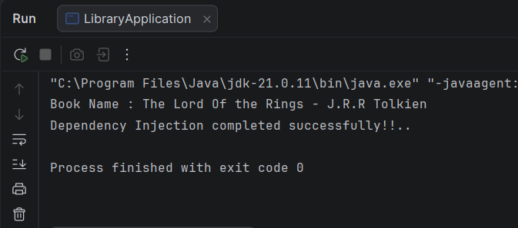

Screenshots
- Project Structure
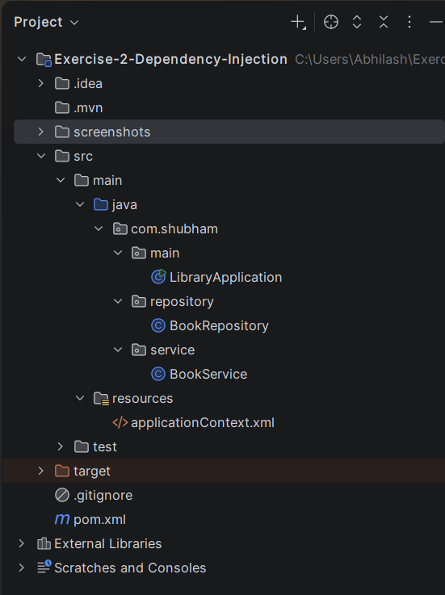

- pom.xml
<?xml version="1.0" encoding="UTF-8"?>
<project xmlns="http://maven.apache.org/POM/4.0.0"
xmlns:xsi="http://www.w3.org/2001/XMLSchema-instance"
xsi:schemaLocation="http://maven.apache.org/POM/4.0.0
http://maven.apache.org/xsd/maven-4.0.0.xsd">
<modelVersion>4.0.0</modelVersion>
<groupId>com.shubham</groupId>
<artifactId>exercise-2-dependency-injection</artifactId>
<version>1.0-SNAPSHOT</version>
<properties>
<maven.compiler.source>21</maven.compiler.source>
<maven.compiler.target>21</maven.compiler.target>
<spring.version>5.3.39</spring.version>
</properties>
<dependencies>
<dependency>
<groupId>org.springframework</groupId>
<artifactId>spring-context</artifactId>
<version>${spring.version}</version>
</dependency>
</dependencies>
</project>

- applicationContext.xml
<?xml version="1.0" encoding="UTF-8"?>
<beans xmlns="http://www.springframework.org/schema/beans"
xmlns:xsi="http://www.w3.org/2001/XMLSchema-instance"
xsi:schemaLocation="
http://www.springframework.org/schema/beans
https://www.springframework.org/schema/beans/spring-beans.xsd">
<bean id="bookRepository"
class="com.shubham.repository.BookRepository"/>
<bean id="bookService"
class="com.shubham.service.BookService">
<property name="repository"
ref="bookRepository"/>
</bean>
</beans>

- BookRepository.java
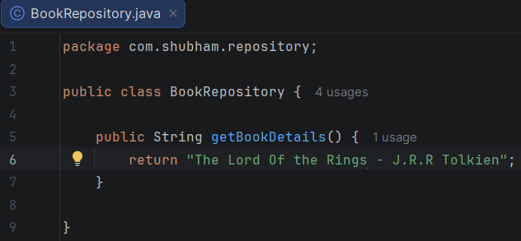

- BookService.java
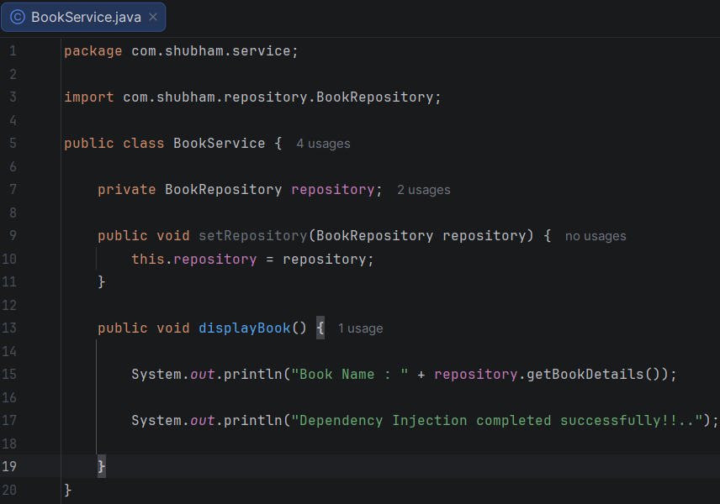

- LibraryApplication.java
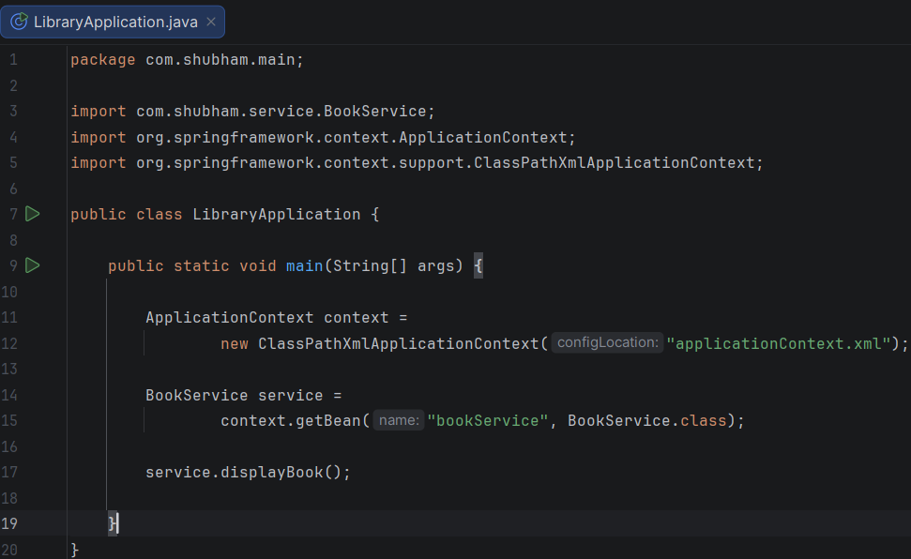

Result
The application successfully demonstrated Setter-Based Dependency Injection using the Spring IoC container. The repository bean was injected into the service bean, and the application executed as expected.

Conclusion
The experiment successfully demonstrated the concept of Dependency Injection in Spring. By using XML configuration and Setter Injection, the application achieved loose coupling between classes, making the code more modular, reusable, and maintainable.

